Invention Convention ---- An Introduction

Have you ever wondered how the idea for inventions came about? Most inventions are based on a need or desire that people have to make work easier and life more enjoyable, or to service a special need. Cell phones, the internet, and palm pilots are only a few of the many inventions that make it convenient for us to communicate and organize our days.

And, who are these people working to make our work easier and our lives more enjoyable? They are engineers! An engineer is a person who designs and builds complex products, machines, systems, or structures. Engineers want to know how and why things work. They have scientific training that they use to make practical things to help society.

Engineers often specialize in a specific branch of engineering. As a result there are many different kinds of engineers. In the past, engineering was divided into four major branches: Mechanical, Chemical, Civil and Electrical, with sub branches of each discipline. Today, however, there are a lot of different kinds of engineers, and there will be new kinds in the future as technologies are reshaped and invented to solve new challenges around the world. What kind of engineering problem would you like to solve or would you perhaps invent something to solve this problem.

The Engineering Design Process
The engineering design process is a series of steps that engineers follow to solve a problem. Many times the solution involves designing a product (like a machine or computer code) that meets certain criteria and accomplishes a task.
A project that involves designing, building, and testing something follows the Engineering Design Process. The steps of the engineering design process are described in the diagram.
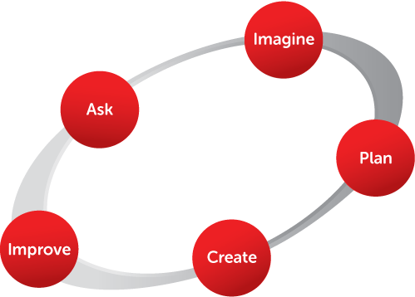

What does each step mean?
Ask what is the problem? Define the problem --- put the problem into a clear, well defined and explicit statement. state requirements and specifications.
Imagine possible solutions. Brainstorm ideas. Choose the best one and research it. Information needs gathering! Has this problem been encountered before? What solutions already exist for this problem? How effective or ineffective are current solutions to this problem? Doing good research will save you time and effort later.
Plan the best possible solution. Draw a diagram. Make a list of materials you will need. Identify your constraints and criteria. Write a procedure.
Create your prototype --- the first of its kind! Follow your plan and create something. Test it out! Analyze the results. Determine how effective or ineffective your design is. Identify the advantages and disadvantages of your design and whether to use it. Be objective in your evaluations.
Improve your design. Identify what works? What doesn't? What could work better? Make adjustments. Modify your design to make it better. Redesign or rebuild your prototype. Test it out! Re-evaluate. If tests are positive, the design can then be implemented.
This process is highly iterative. Once a prototype is tested and evaluated you may find your solution to the problem isn’t as great as you thought and you have to go back and do more research. More information may help you redefine your problem. Or you may have to redesign your prototype and test again. Engineers get caught up in this process and continuously repeat and reiterate until the ultimate solution reveals itself and is implemented.
Dear Parents,
As a 7th grade St. Christina student your child will be participating in our Invention Convention to be held Tuesday March 13, 2018. It is designed to promote your child's problem-solving and creative-thinking skills. Your child will be following a step-by-step process to invent a new product, develop a new procedure for doing something, or redesign a manufactured good already on the market.
Students will follow a procedure used by engineers called the Engineering Design Process. The first step in the actual process involves finding an idea for an invention. Once your child has decided upon an idea and researched it to make sure that the idea has not been used before, the actual planning, designing and building take place. When the prototype is completed, your child will test the design, evaluate it and make necessary adjustments, minor changes or major modifications and test again.
As your child begins the actual process of inventing, your continued interest and your encouragement will be helpful. Discuss the progress your child is making and any problems that are encountered. Remind your child that although inventors often experience failure along the way, they remain persistent and keep trying and thinking of new ideas to solve a problem.
This long-term assignment will be completed in phases. Various assignments will be due on specific dates thereby preventing students from waiting until the last day to complete the project. These dates along with a pacing guide will be provided to your child. Please save all of the papers and help your child plan ahead and to hand in all assignments on time.
Students may work independently or with a partner. If your child chooses to work with a partner, I encourage you to discuss with your child his or her choice of partner. This project will be completed at home and the student teams will need to meet with each other so that they are able to work together. You may feel that adult supervision is crucial --- will you be available to oversee or assist, if necessary? Both partners need to assume equal responsibility in completing this assignment and not assume that the other person will do all of the work.
As stated above the Invention Convention will be held on Tuesday, March 13th. Specific times will be sent out closer to the event. You are invited to attend the event. Each student's entry will be judged as will the student's knowledge of his or her invention. We know your child will enjoy and benefit from this experience in scientific problem solving. We hope to see you at the Invention
Thank you for your assistance.
Mrs. Simpson
Invention Convention: Technology and Design Assessment

You are going to create your own invention that includes one or more simple machines. It can be a totally new invention or an improvement of an existing innovation. Please follow the directions and due dates below:

- Brainstorm Form Due Monday, December 18, 2017
Look around your house, your neighborhood or school. Think about objects that might need improvement, or about tasks that could be improved if you had a certain device. Write some ideas about things you could create to improve your life. Use the Brainstorm Form.

- Technology Challenge Diagram Form Due Tuesday, January 9, 2018
Choose one of your ideas. List it as a challenge on the Technology Challenge Diagram Form. Next, brainstorm several possible solutions and record them. List materials that you will need and the steps you will take to invent something to solve the challenge. On the back of the paper, make a rough sketch or diagram of your ideas. Label the parts.

- Invention Intention Form Due Wednesday, January 31, 2018
Use your idea to complete the What’s My Intent? To Invent! form. This is the invention that you will be creating. You should also think of a name for your invention.

- Invention and Poster Due Thursday, March 8, 2018
Build a model of your invention. Your model does not need to work. It just needs to represent your idea of the invention. You may have help from anyone as long as the ideas, illustrations, and descriptions are your own.
Poster size: 22” x 28” or a small tri-fold (available at the Dollar Store). Your poster should include your name, the title of the invention, what is does, an explanation of how your invention works, and a diagram of your invention with parts labeled.

- Presentation Due Tuesday, March 13, 2018
Be ready to present your design to the judging panel. Use of note cards is acceptable.

Name_______________________________HR________

Invention Convention Assignment Record

This pacing guide is designed to help you plan your time and complete assignments by the due dates.

Assignment | Due Date | Completed | Questions I have…
Brainstorm Form | December 18, 2017 Monday
Technology Challenge Form and Diagram | January 9, 2018  Tuesday
Invention Intention Form | January 31, 2018 Wednesday
Invention and Poster | March 8, 2018 Thursday
Presentation | March 13, 2018  Tuesday

Additional Notes ---

The Invention Convention Judging Form

Name of Inventor________________________________________________

Title of Invention________________________________________________

Judge_________________________________________________________

Circle the appropriate rating (5 being the highest)

- Does this invention identify and address a problem?
5 4 3 2 1

- How well has this inventor done research and provided evidence to show that no similar process or product exists?
5 4 3 2 1

- How knowledgeable and enthusiastic is the inventor about the invention?
5 4 3 2 1

- How well is this invention designed and constructed?
5 4 3 2 1

- How effectively has the inventor advertised (back board) the invention?
5 4 3 2 1

- How effectively has the inventor presented the invention?
5 4 3 2 1

- How knowledgeable is the inventor of the Engineering Design Process?
5 4 3 2 1

Total Points _______

Name_________________________________________HR________

Brainstorm Form --- Due December 18, 2017
Ask yourself the following questions and you’re on your way to thinking about a new invention! Think about home, chores, school and leisure activities.

What are your3 biggest problems?
Problem 1 | Problem 2 | Problem 3

What 3 tasks can I make easier?
Task 1 | Task 2 | Task 3

What 3 objects do I use that could work better?
Object 1 | Object 2 | Object 3

What are my 3 favorite things to do, and what would make them even more fun and interesting?
Favorite 1 | Favorite 2 | Favorite 3
Name_________________________________________HR________

Technology Challenge Diagram Form --- Due January 9, 2018

Define Your Problem ---

Brainstorm Possible Solutions --- Include Your Research ---

List Materials You Will Need ---

List the steps you will take to invent something to solve this challenge ---

Use the back of this paper to make a rough sketch or diagram of your possible invention. Be sure to label the parts and identify any simple machines used.
Name_________________________________________HR________

Invention Intention Form --- Due January 31, 2018

Name of Your Invention ______________________________________________

What is the function or purpose of this invention? _________________________ __________________________________________________________________
__________________________________________________________________
__________________________________________________________________
__________________________________________________________________

Describe the problem or improvement that inspired your invention. What are the reasons for inventing this particular invention? ____________________________
___________________________________________________________________
___________________________________________________________________
___________________________________________________________________

Who is your target audience? __________________________________________
___________________________________________________________________
___________________________________________________________________

How will your invention help you and others? _____________________________
___________________________________________________________________
___________________________________________________________________
___________________________________________________________________

What topics did you research to make sure your invention is authentic? ___________________________________________________________________
___________________________________________________________________
___________________________________________________________________

List 3 sources you used in your research. ___________________________________________________________________
___________________________________________________________________
___________________________________________________________________

Materials and tools needed to make a model of the invention. ________________
___________________________________________________________________
___________________________________________________________________
___________________________________________________________________

How will you make your invention? Number and list all the steps you need to take to make the model of your invention. ___________________________________________________________________
___________________________________________________________________
___________________________________________________________________
___________________________________________________________________
___________________________________________________________________
___________________________________________________________________
___________________________________________________________________
___________________________________________________________________
___________________________________________________________________
___________________________________________________________________
___________________________________________________________________
___________________________________________________________________
___________________________________________________________________
___________________________________________________________________
___________________________________________________________________
___________________________________________________________________
___________________________________________________________________
___________________________________________________________________
___________________________________________________________________
___________________________________________________________________
___________________________________________________________________
___________________________________________________________________
___________________________________________________________________
___________________________________________________________________
___________________________________________________________________

Additional information you would like to add.
___________________________________________________________________
___________________________________________________________________
For Your Presentation --- You may use note cards or a sheet of paper to answer the following questions.

- Give a detailed description of your invention.

- Describe and list the materials of your prototype.

- Summarize how you constructed your invention.

- List the problems you encountered and explain how you solved them.

- Give a detailed “pitch”. Include what the problem is and how your product is the solution. This should convince people that they cannot live without your product.

Some Finished Product Suggestions
Be sure to make plans for displaying your invention at the Invention Convention on Tuesday, March13th.

Required
- A prototype of your invention
- An attractive and neat display that is easily read

For Extra Credit (Select one)
- Construct up-scale packaging for your invention
- Create an advertisement for your invention
- Design a promotional brochure for your invention

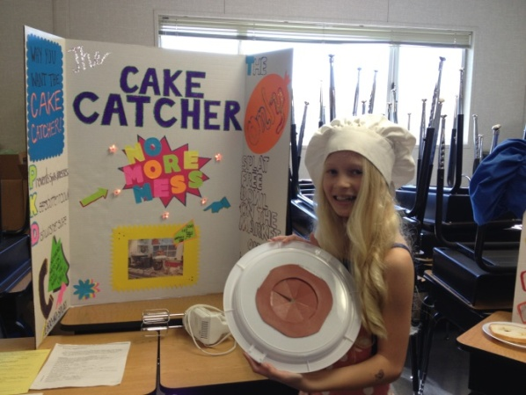
Invention Convention Rubric
Student Name: | Not at all | Somewhat | Very much
Invention was original | 1 | 2 | 3
Invention was possible | 1 | 2 | 3
Invention was something someone would desire to use | 1 | 2 | 3
Poster was neat and attractive | 1 | 2 | 3
Poster was grammatically correct and readable | 1 | 2 | 3
Poster was creative | 1 | 2 | 3
Student projects voice, uses eye contact and engages listener throughout presentation | 1 | 2 | 3
Student is prepared and displays confidence during presentation | 1 | 2 | 3

Total = _________ Grade = _________

